Wheel of Measure
Discover some little-known facts about your home when you play "Wheel of Measure"! First, you'll create the measuring wheel from a paper plate; then, you'll use it to measure objects around the house -- that's doing it the fun way.
Once you've found out how long or wide things are, play the Wheel of Measure game by quizzing your family and friends. See whose guess is closest to the actual measurement.
What You'll Need
Cloth measuring tape
Marker
Stiff paper plate
Ruler with hole at one end
Paper fastener (also called a brad)
How to Make the Wheel of Measure
Step 1: Use a cloth measuring tape to mark off the inches around the paper plate.
Step 2: Attach the middle of the paper plate through the hole in the ruler with a paper fastener.
Step 3: Run your measuring wheel along any surface to see how long the surface is in inches. Count how many times the wheel goes around from one end of a surface to the other, and multiply by the number of inches you marked on the wheel.
For example, did you mark off 12 inches on your wheel? If a 12-inch wheel goes around 4 times from one end of a table to the other, then the table is 48 inches long (12 x 4 = 48). Now, start the quiz game!
Do you think you'd get lost in a maze? Play the "A-Maze-ing" maze game to see if you can find your way out. Keep reading to learn more.

A-Maze-ing
A "maze" is a confusing network of passages, and that's what makes this game truly "a-maze-ing." When you create your own maze game to play with your friends, you can make the passages are difficult or confusing as you like.
Follow the easy instructions below to create the maze game -- but it won't be as easy for your friends to find their way out of your maze!
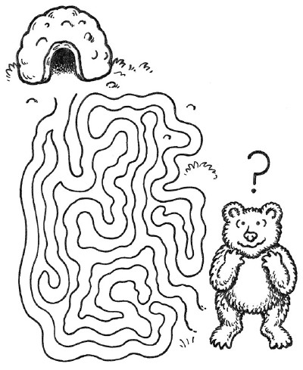
Try your luck with this "a-maze-ing" game.
What You'll Need
Pencil
Tracing paper
Black felt-tip pen
Graph paper
Colored pencils
How to Make the A-Maze-ing Maze Game
Step 1: Use a pencil to draw a zigzag track on tracing paper. Add detours and dead ends off the track, and add more tracks that go nowhere. You can also make more maze tracks that are curved or triangular.
Step 2: Once you've completed the maze, go over it with a black felt-tip pen.
Step 3: Then trace over your maze with graph paper so that you won't see any pencil marks.
Step 4: Add a drawing at the entrance and exit, such as a lost bear looking for its den. Color the maze with colored pencils.
Step 5: Make copies of your maze game, and give it to your friends to play.
Long car trips don't have to be boring -- not when you can play auto bingo. Keep reading to find out more.

Jazzy Jigsaws
When you and your kids make Jazzy Jigsaws, you'll have just as much fun as when you solve the puzzle. You can also mail these nifty jigsaws to family or friends as surprises.
How to Make Jazzy Jigsaws
What You'll Need:
- Thin Poster Board
- Pencil
- Photo, Magazine Picture or Drawing;
- Glue Stick
- Scissors
Step One: Start small at first, to perfect your puzzle-making prowess. Cut the poster board to your desired finished size.
Step Two: Next, cut a photo or picture to the size of the poster board. Glue the photo or picture to the board with the glue stick.
Step Three: On the backside of the poster board, about 1 inch from the left edge, draw a zigzag line from top to bottom with a pencil. Draw a similar line 1 inch away from that, and continue across the board.
Step Four: Now draw zigzag lines from side to side, about 1 inch away from each other. Cut along each line. Turn each puzzle piece face up.
Step Five: Put together your own designer jigsaw creation!

The Great Adventure
The Great Adventure is a challenging educational game that you can make with your kids. Bring your favorite action hero or heroine to life.
How to Make The Great Adventure
What You'll Need:
- Action Figure
- Heavy Poster Board
- Pencil
- Thick Black Marker
- Paints and Paintbrushes or Colored Markers
- Clear Adhesive Vinyl
- Thin Poster Board
- Scissors
- Game Pieces from other Board Games or Colored Glass Pebbles
- Die
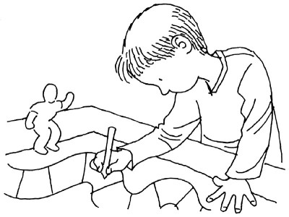
Help your kids create challenges for their heroes in The Great Adventure.
Step One: Come up with an adventure for your favorite hero or heroine action figure. Give him or her a goal to reach and several funny obstacles along the way.
Step Two: Sketch in the starting point in a corner of the poster board and the end in the opposite corner. Draw scattered obstacles in the middle. Draw a path, with marked spaces big enough for your game pieces, between the starting point and the end. Mark some spaces "hazard."
Step Three: Finish coloring in the board with markers or paints. Let dry. Cover with clear adhesive vinyl for lots of use. Use the thin poster board to make hazard cards to turn over when you land on one of these spaces.
Step Four: Name the hazard and the penalties, such as "Lose a turn," "Go back 2 spaces," "Start over," etc.
Step Five: Grab your game pieces, roll the die, and begin the adventure!

Pictominoes
Pictominoes are colorful dominoes that you and your kids can make together. Custom-make your dominoes with pictures instead of dots.
How to Make Pictominoes
What You'll Need:
- Index Cards in White or Pastel Shades
- Ink Pads
- 6 Small Rubber Stamps
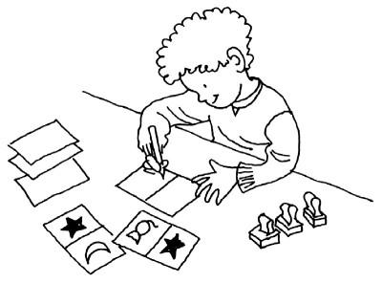
Create colorful images on your Pictominoes cards.
Step One: Count out 28 index cards. On the blank side of each card, draw a line through the middle from one long side to the other.
Step Two: Take one of the ink stamps and make prints on 1 side of 4 of the index cards. Do the same with the rest of the ink stamps.
Step Three: This should leave you with 4 random spaces that are blank. That's OK; these are wild spaces.
Step Four: Play with your "pictominoes" as if they had dots, only match up the pictures instead!

How to Make No-Bored Games
What You'll Need:
- Poster Board
- Scissors
- Markers
- Index Cards
- 6 Craft Sticks
- Small Plastic Cup
Step One: On the poster board, draw a snakelike road. Divide it into squares.
Step Two: Color each area with one of 6 colors. Draw dinosaurs, volcanoes, swamps, and tar pits alongside the road. Write "Jump ahead 1" or "Go back 1" on some squares. Draw question marks on 5 squares.
Step Three: On each index card, write a question about dinosaurs. If you land on a question mark, you must answer a question about dinosaurs to move.
Step Four: Make pick sticks to move. Color the bottom 1 inch of each craft stick with one of your 6 colors. Put the sticks, color side down, in the small plastic cup. Draw 1 pick stick to see what color you move to.

Find the Presents
When you and your kids play Find the Presents, you'll find out who is the family mastermind. In this game of strategy, race your opponent to locate the hidden presents.
How to Make Find the Presents
What You'll Need:
- Drawing Paper
- Ruler
- Markers
- Blunt Scissors
- Construction Paper
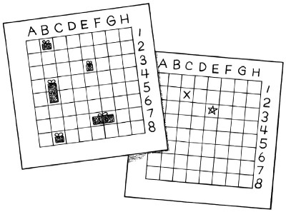
Find the Presents -- a game of skill.
Step One: To make the game board, draw an 8 x 8-inch square on a piece of drawing paper. Divide the square into 64 squares, 1 inch each, by drawing lines 1 inch apart down and across. There should be 8 squares down each side.
Step Two: Label the rows across A through H and label the columns down 1 through 8 as shown. Have an adult take your original to a copy center and make 4 copies -- you'll need 4 copies to play 1 game. (Save your original game board to make more copies later.)
Step Three: On a piece of construction paper, draw 10 presents. Make four 1 x 2-inch presents, and six 1 x 1-inch presents. Decorate your presents and cut them out.
Step Four: Each player gets 2 large presents, 3 small ones, and 2 game boards.
Step Five: To play the game, arrange your presents on 1 game board. Then take turns guessing the location of your opponent's presents by calling out the name of the square. For example, you might ask if the present is in E-3. If the answer is no, mark the E-3 spot on your blank game board with an X; if the answer is yes, mark it with a star.
Step Six: Then your friend takes a turn. The first person to find all the presents wins.

Matrix Game
The Matrix Game is a great project for you and your kids. This challenging puzzle game tests your strategic ability as well as your patience.
How to Make the Matrix Game
What You'll Need:
- 10 x 10-inch Piece of Poster Board
- 12 x 12-inch Piece of Poster Board
- Ruler
- Markers
- Blunt Scissors
Step One: Trace the outline of the small poster board on the large poster board. Draw a line every 2 inches on the small poster board up and down and across to make a matrix of 25 squares. There should be 5 squares down each side.
Step Two: Draw a picture on the small poster board, filling up all the squares except the one in the bottom right corner. Draw a small dot in the top left corner of each square.
Step Three: Cut out the squares. Throw away the blank bottom right square. Place the squares within the outline you drew on the large poster board. Mix the squares up, but keep all the dots in the top left corner.
Step Four: Re-create your picture by rearranging the squares one space and one square at a time.

Fractional Pizza Game
The Fractional Pizza Game is a great way to teach your kids basic math skills. These pizzas may not taste great, but the fun they serve up is absolutely delicious.
How to Make the Fractional Pizza Game
What You'll Need:
- Paper Grocery Bags
- Blunt Scissors
- Markers
- Ruler
- Construction Paper
- Paste
- Dice with fractions (See Giant Dice)
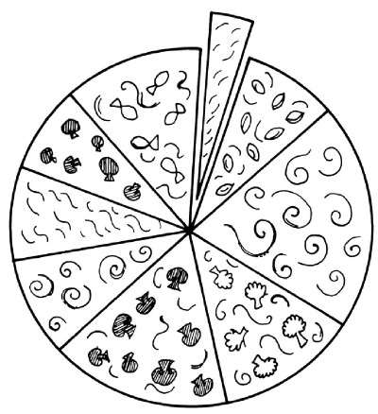
The Fractional Pizza Game teaches kids how big fractions really are.
Step One: Cut 6 circles the same size from the grocery bags to make paper pizzas. On construction paper, draw your favorite pizza toppings such as pepperoni, mushrooms, sausage, and tomatoes. Cut the toppings out and paste them on the paper pizzas.
Step Two: With a marker, divide your pizzas into these fractions: 1/2, 1/3, 1/4, 1/6, 1/8, and 1/12, and cut the "slices." (You may need an adult's help to make sure your slices are even.)
Step Three: See Giant Dice, and make a die with fractions on its 6 sides.
Step Four: To play the game, roll the die and select the slice size it shows. The first person to assemble a whole pizza wins!

funbrain.com Grammar Gorillas
The Grammar Gorillas show you fun sentences and ask you to find the noun, verb,
etc. A parts of speech game.
http://www.funbrain.com/grammar/index.html

Basic Skill Practice Games
Stufun Grammar Games · Intermediate Grammar Practice · High School Grammar Rules ·
Grammar Games · Grammar Crackers · 2Bee or Nottoobee ...
http://classroom.jc-schools.net/basic/la-grammar.html

Parts of Speech Games
Nouns Game 5 · Nouns Game 6 · Verbs Game 1 · Verbs Game 2 · Verbs Game 3 ·
Adjectives and Adverbs · Prepositional Phrases · Grammar Blast Review 1 ...
http://www.gamequarium.com/partsofspeech.html

Brain Versus Calculator
 |  |  | 
 |  |  | 


Do you have enough math smarts to beat a calculator? Could the type of math problems you're given have anything to do with your chances? Try your skills in the Brains Versus Calculator game.
Materials: calulator (provided below); a penny or other marker; math problems (follow links below)
Number of Players: 3
Directions:
1) One player is the "caller," a second player is the "brain," and the last player is the "calculator."
2) Make a list of math problems or print out the problems we have provided [Primary Problems (ages 5-8) or Intermediate Problems (ages 8-12)]. If you make up your own, choose your problems based on your ability level. Primary kids should stick to 1 digit adding and subtracting while older kids should include multiplication and division problems.
3) Have the "caller" drop a penny or some other marker on the problems. The "caller" calls out the problem.
4) The "calculator" MUST use the on-line calculator shown below to solve the problem (even if they know the answer) and the "brain" must figure out the answer in their head. Say the answer out loud as soon as you can.
5) The "caller" decides who said the answer the fastest.
6) Switch jobs every 10 problems or so. Good luck!
7) How did you do? Work on building your fact power so that you can beat the calculator.

Free JavaScripts provided

